GitHub

Session#1 Link:
https://www.youtube.com/watch?v=qLrx6wkM5Ig

Introduction: -
GitHub is a code hosting platform for version control and collaboration. It lets you and others work together on projects from anywhere.

GitBash: -
It is local client software used to connect with Git Vendors.
https://git-scm.com/downloads

We can do GitHub essentials like repositories, branches, commits, and pull requests.
What we can do here is:
- Create and use a repository
- Start and manage a new branch
- Make changes to a file and push them to GitHub as commits
- Open and merge a pull request

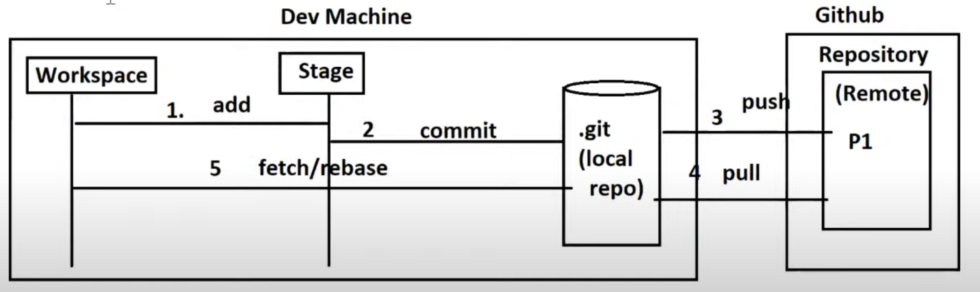

Repository: -
A repository is usually used to organize a single project. Repositories can contain folders and files, images, videos, spreadsheets, and data sets -- anything your project needs. Often, repositories include a README file, a file with information about your project.
Remote Repository is common to all developers where as Local Repository (.git) is specific to developer machine.

Branch: -
Branches are used to manage separate code basis for every developer or client or features. We can create a branch, commit changes and merge to another branches. Every branch created at local must be connected with remote branch (ie called as origin branch), we can connect them using –set-upstream.
*In real world, deleting branches are not recommended. It is always better to create new branch for new features, client fixes, stage environment, ..Etc

Stage: -
The staging area can be described as a preview of your next commit. When you create a git commit, Git takes changes that are in the staging area and make them as a new commit. You are allowed to add and remove changes from the staging area. The staging area can be considered as a real area where git stores the changes.

Cheat Sheet Links: -
https://education.github.com/git-cheat-sheet-education.pdf
https://training.github.com/downloads/github-git-cheat-sheet.pdf

